2014 08 27 Germany’s Expensive Gamble on Renewable Energy

Companies Worry Cost of Plan to Trim Nuclear, Fossil Fuels Will Undermine Competitiveness
By
MATTHEW KARNITSCHNIG
Aug. 26, 2014 10:30 p.m. ET
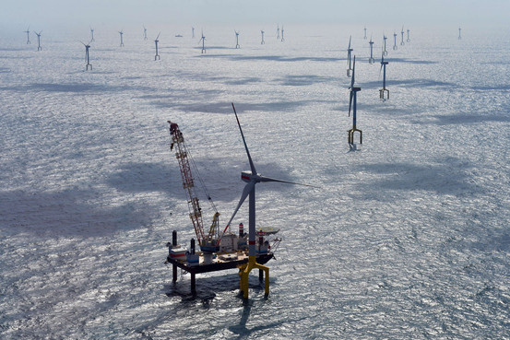
Germany's biggest North Sea wind farm, Bard 1, has 80 turbines and is expected to produce enough energy to power a city the size of Munich. Agence France-Presse/Getty Images
WILSTER, Germany—In a sandy marsh on the outskirts of this medieval hamlet, Germany's next autobahn will soon take shape.
The Stromautobahn, as locals call it, won't carry Audis and BMW's , but high-voltage electricity over hundreds of miles of aluminum and steel cables stretching from the North Sea to Germany's industrial corridor in the south.
The project is the linchpin of Germany's Energiewende, or energy revolution, a mammoth, trillion-euro plan to wean the country off nuclear and fossil fuels by midcentury and the top domestic priority of Chancellor Angela Merkel.
But many companies, economists and even Germany's neighbors worry that the enormous cost to replace a currently working system will undermine the country's industrial base and weigh on the entire European economy. Germany's second-quarter GDP decline of 0.6%, reported earlier this month, put a damper on overall euro-zone growth, leaving it flat for the quarter.
Average electricity prices for companies have jumped 60% over the past five years because of costs passed along as part of government subsidies of renewable energy producers. Prices are now more than double those in the U.S.
"German industry is going to gradually lose its competitiveness if this course isn't reversed soon," said Kurt Bock, chief executive of BASF SE, the world's largest chemical maker.
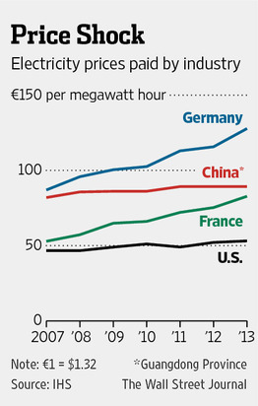

More
- German Consumer Confidence Seen Falling in September
The European Union has set a series of binding renewable energy targets for all of its members. The goals, in which about 35% of Europe's electricity is projected to come from renewable sources by 2020, are considered ambitious by international standards. But Germany's "lonely revolution," as some call it, goes much further. By 2025, Germany aims to produce 40%-45% of its electricity from renewable sources, rising to at least 80% by 2050. Most countries in the EU are holding to the lower target for now and are continuing to use nuclear energy.
Ms. Merkel, who ordered Germany's accelerated exit from nuclear power after the Fukushima disaster in 2011, has declared the Energiewende both a major contribution in the battle against global warming and a historic step toward ending the world's reliance on nuclear power.
"No country of Germany's scale has pursued such a radical shift in its energy supply," Ms. Merkel said in a speech earlier this year. "I'm convinced that if any country can successfully implement the Energiewende, it's Germany."
One government estimate projects the Energiewende by 2040 to cost up to €1 trillion, or about $1.4 trillion, or almost half Germany's GDP and nearly as much as the country spent on the reunification of East and West Germany.
Despite the weak second quarter, Germany's economy—Europe's largest—is still benefiting from strong demand for German machinery and autos in China and elsewhere, which helped Germany weather the Continent's debt crisis with little damage. This year, the economy is expected to expand by about 1.5%, solid growth by European standards.
Yet nearly 75% of Germany's small- and medium-size industrial businesses say rising energy costs are a major risk, according to a recent survey by PricewaterhouseCoopers and the Federation of German Industry.
A similar percentage of the U.S. companies operating in Germany said the Energiewende had made the country a less attractive place for business, according to a separate poll by the U.S. Chamber of Commerce. And for the first time since 2008, German companies cited rising overall costs at home as a motivation to invest abroad in a recent survey by the German Chambers of Commerce and Industry.
"Germany's current path of increasingly high-cost energy will make the country less competitive in the world economy, penalize Germany in terms of jobs and industrial investment, and impose a significant cost on the overall economy and household income," warned Daniel Yergin, vice chairman of research firm IHS.
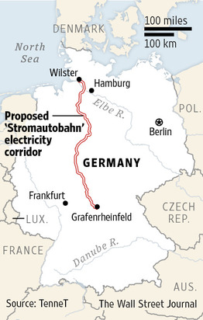
The German government says it is committed to limiting the negative impact on the broader economy. Once Germany's renewable infrastructure is complete, electricity prices should fall, the government has said.
The government also argues that by establishing German industry as the leader in green technology, the Energiewende will give German business another lucrative export. Ms. Merkel has pointed to eventual technological advances in solar and wind power generation, grid management systems and power storage technologies.
BASF, which consumes as much electricity every year at its main German plant as the entire country of Denmark, said in May it would substantially reduce its investments in Germany as a result of the country's energy policy. It said its plan for the next five years is to cut investment in Germany to one-fourth the €20 billion global total investment, from one-third currently, and that it would invest in Asia and the U.S. instead. BASF has more than 50,000 employees in Germany, about half the company's total workforce.
SGL Carbon, a maker of carbon-based products, in May decided to invest an additional $200 million to its plant in Washington state on top of $100 million previously invested instead of investing in its home base of Germany. The company, which makes carbon fibers used to lighten the body of BMW's new electric car at the Washington facility, said electricity at the site costs less than one-third German rates.
Basi Schöberl GmbH, an industrial gases company based in southwestern Germany, shelved plans this year to expand production at home. Instead, it will invest more than €10 million to build out its French base near Strasbourg. An investment in Germany was too risky due to uncertainty over government policy and the effect the Energiewende will have on energy prices, said Chief Executive Ingo Nawrath. "We're standing with our backs up against the wall," he said.
So far, the main beneficiaries of the Energiewende are investors in wind and solar installations. Private individuals and local community groups control about half of Germany's onshore wind and solar energy markets. Institutional investors, including many insurance companies, own roughly half of the country's solar energy and 40% of its onshore wind power generation. Germany has few hydropower resources.
Rewiring the world's fourth-largest economy hasn't been easy. The undertaking, the biggest infrastructure project in Germany since World War II, has been plagued by cost overruns, regulatory disputes and questions of conservation. One issue: how to keep bats and endangered birds from flying into the rotors of thousands of wind turbines going up across the country.
A more immediate concern is the soaring cost of energy.
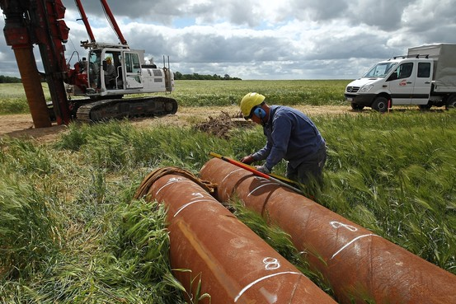
A worker constructs an electrical transmission tower near Lüssow, Germany, that will transmit power generated by offshore wind farms. Getty Images
To encourage the expansion of green power production, the government guaranteed prices for electricity fed into the grid from renewable sources, such as wind turbines or solar panels. The price guarantees, which vary depending on when the system was installed and its generating capacity, are binding for 20 years.
The government passes the subsidy cost on to consumers in a surcharge. While the flood of new energy sources has lowered market prices for electricity, consumer prices have actually increased as the surcharge has risen to make up the difference between the market and government-guaranteed prices. On the spot market, a kilowatt-hour of electricity costs 3.2 cents, half what it did in 2011. The average guaranteed price under the government's price fixing regime is 17 cents. The renewable energy surcharge levied on German households and businesses has nearly tripled since 2010 and now accounts for about 18% of a German household's electric bill. All told, the subsidies amount to about €24 billion a year, according to Germany's economics ministry.
Alarmed by the rising costs, Ms. Merkel's government revised the law authorizing the green energy subsidies in June. With a combination of caps on the number of new solar and wind installations eligible for the subsidy and other measures, it hopes to forestall further surcharge increases.
About 2,000 of Germany's heavy industrial users—including BASF and SGL—are largely exempt from paying the surcharge until at least 2017, when the EU wants to scrutinize whether the exemption is an unfair trade support, among other issues.
Berlin has vowed to fight any attempt by the EU to fundamentally change the subsidy program.
The companies, which save about €5 billion annually because of the surcharge exemption, say the questions surrounding the program make it impossible to plan and say the higher energy costs are passed on to them from smaller suppliers and contractors who aren't exempted.
Nonexempt companies also complain of the disparity. "Whereas some sectors are exempt from the renewable-energy surcharge, high-tech companies have to bear an additional burden,"Infineon Technologies AG Chief Executive Reinhard Ploss complained to investors earlier this year. Mr. Ploss said his company, Germany's largest chip maker, would pay €25 million less in Austria for the power it uses in Germany this year.
The incentives, introduced in 2000, have worked to increase renewable-energy production. Wind turbines now dot the horizon in almost every corner of the country. Farmers and suburbanites from Bavaria to Berlin have installed solar panels on their barns and homes to earn extra money from the government subsidy.
But not all rollouts have been smooth. In the north, to protect Germany's shoreline ecosystems and ocean views, the government ordered wind parks be built as far as 60 miles off the coast. Rough conditions in the North Sea, coupled with depths of more than 150 feet have hampered the projects and sent costs soaring.
Last August, Germany's biggest North Sea wind park went into operation, three years over schedule and with a price tag of about €3 billion, nearly double the projected cost. Called Bard 1, the farm's 80 turbines can produce enough electricity to power Munich. But a fire in a transmission station in March and other problems forced it to shut down.
Bard's management says that it hopes to get the wind park up and running by September and that it has put together a task force to determine the cause of the technical problems.
Overall, distributing the power has proved more complicated than producing it. Electricity generated from wind in Germany's gusty northern reaches must be moved to the country's energy hungry industry in the south.
Germany doesn't have a single north-south power transmission corridor. The country's grid evolved over decades around local power plants that served their communities so there was no need to send power across long distances.
The government wants to build and modernize more than 4,000 miles of high-voltage power lines, both offshore and through densely populated areas. So far, amid delays and indecision, only 220 miles of the expansion have been completed, meaning power can't get to users.
Günther Oettinger, Europe's top energy official, compares Germany's strategy to building a train station before the tracks have been laid. Germany has built "wind park after wind park after wind park" instead of focusing on how it will transmit the electricity to where it is needed, he said.
Winning over local communities along the main grid corridors is the biggest hurdle toward construction.
The Wilster Marsh is the on-ramp for the Stromautobahn, which translates as "electricity highway," and would be a 500-mile-long north-south corridor. The region, a windswept landscape of dairy farms about 45 miles north of Hamburg on the Elbe River, is where the power from more than 1,000 off- and onshore wind farms will flow through a converter station and be shipped south.
Though most locals here support the Energiewende, few want to see 230-foot transmission towers in their neighborhood.
"Some people who were for this are now on their back foot saying, 'but not in my backyard,' " said Matthias Block, the chief of Wilster's department of building.
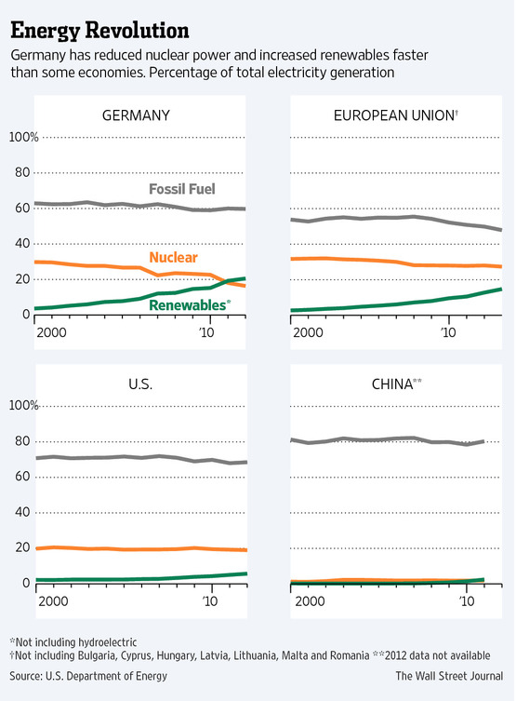
At a recent meeting in Bad Brückenau, a resort town in northern Bavaria, officials of TenneT, the state-owned Dutch company building the transmission corridor, were greeted by hundreds of protesters carrying noisemakers and homemade signs saying "Stop the power-line madness" and other slogans. A score of similar citizen groups have sprouted along the Stromautobahn route.
"The corridor they're planning would destroy everything we've done to improve the environment in this region," said Ingo Queck, a local organizer of a citizen action committee that wants to prevent construction of the line.
Mr. Queck and the other groups worry power lines will destroy the landscape and make the region unattractive for tourism, and say radiation from the high-voltage lines could damage health. TenneT says the electromagnetic radiation from the lines would be well within accepted limits and say it has taken pains to ensure as little impact as possible to the environment by proposing a corridor along existing infrastructure, such as highways.
Polls show strong support in Germany for the Energiewende. Germans' embrace of renewable energy is rooted in their visceral opposition to nuclear power. The movement has been gathering strength since the 1960s, and popular and political opposition was intensified after a violent confrontation between police and 100,000 demonstrators against a new nuclear power plant in 1981 in the Wilster Marsh.
With Germany's nine remaining nuclear power plants set to be closed by 2022, a substantial delay in building the transmission corridor could force the country to revert to conventional energy sources.
The nuclear exit has already triggered an increase in Germany's greenhouse gas emissions over the past two years, because utilities have turned to cheap coal to replace the power capacity lost from the eight nuclear plants that have already been switched off.
The government says the trend is temporary and that emissions will drop once more wind and solar farms go into operation.
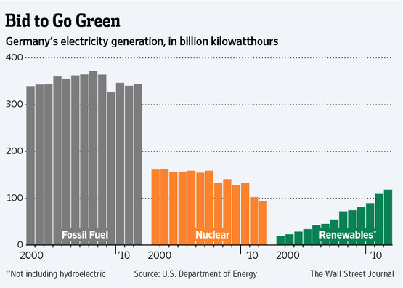
But critics say "grid instability," or the unpredictable nature of renewable power, could force the continued use of coal plants.
Because the technology is so new and no one has ever built a renewable-based infrastructure on this scale before, there is concern among industry about the reliability of the electricity supply—in precision manufacturing, a power loss for even a millisecond can throw a production line out of kilter. That presents a particular risk for companies such as Infineon and other tech hardware companies.
Skeptics, meanwhile, say the program's overall environmental impact will be limited if other big countries don't follow suit. Germany accounts for just over 2% of global greenhouse gas emissions.
In June the EU admonished Berlin to "keep the overall costs of transforming the energy system to a minimum" and said Germany needed to do more to coordinate its energy policy with neighboring countries, which worry about the stability of their own infrastructure.
"Initially, there was this enthusiasm that Germany would be at the head of the parade," said IHS's Mr. Yergin, who has chronicled the global energy sector for decades. "But now the Germans look back and see there aren't that many people behind them."
Write to Matthew Karnitschnig at matthew.karnitschnig@wsj.com web source: http://online.wsj.com/articles/germanys-expensive-gamble-on-renewable-energy-1409106602?mod=WSJ_hp_RightTopStories

