2014 08 25 It’s Time to Take Artificial Intelligence Seriously

No Longer an Academic Curiosity, It Now Has Measurable Impact on Our Lives
By
Christopher Mims
Aug. 24, 2014 7:24 p.m. ET
A still from "2001: A Space Odyssey" with Keir Dullea reflected in the lens of HAL's "eye." MGM / POLARIS / STANLEY KUBRICK
The age of intelligent machines has arrived—only they don't look at all like we expected. Forget what you've seen in movies; this is no HAL from "2001: A Space Odyssey," and it's certainly not Scarlett Johansson's disembodied voice in "Her." It's more akin to what happens when insects, or even fungi, do when they "think." (What, you didn't know that slime molds can solve mazes?)
Artificial intelligence has lately been transformed from an academic curiosity to something that has measurable impact on our lives. Google Inc. used it to increase the accuracy of voice recognition in Android by 25%. The Associated Press is printing business stories written by it. Facebook Inc. is toying with it as a way to improve the relevance of the posts it shows you.
What is especially interesting about this point in the history of AI is that it's no longer just for technology companies. Startups are beginning to adapt it to problems where, at least to me, its applicability is genuinely surprising.
Take advertising copywriting. Could the "Mad Men" of Don Draper's day have predicted that by the beginning of the next century, they would be replaced by machines? Yet a company called Persado aims to do just that.
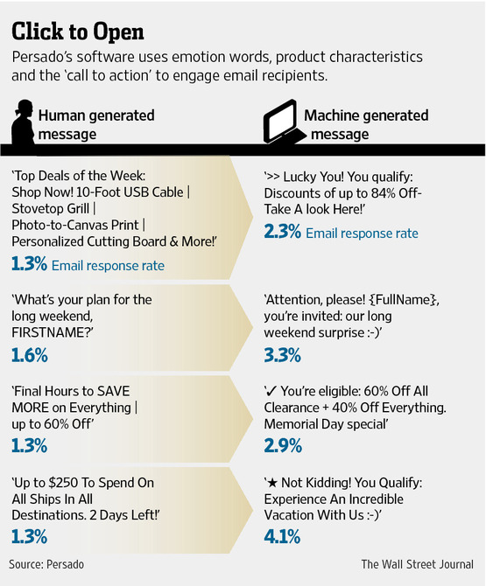
Persado does one thing, and judging by its client list, which includes Citigroup Inc. and Motorola Mobility, it does it well. It writes advertising emails and "landing pages" (where you end up if you click on a link in one of those emails, or an ad).
Here's an example: Persado's engine is being used across all of the types of emails a top U.S. wireless carrier sends out when it wants to convince its customers to renew their contracts, upgrade to a better plan or otherwise spend money.
Traditionally, an advertising copywriter would pen these emails; perhaps the company would test a few variants on a subset of its customers, to see which is best.
But Persado's software deconstructs advertisements into five components, including emotion words, characteristics of the product, the "call to action" and even the position of text and the images accompanying it. By recombining them in millions of ways and then distilling their essential characteristics into eight or more test emails that are sent to some customers, Persado says it can effectively determine the best possible come-on.
WSJD is the Journal's home for tech news, analysis and product reviews.
- Cybercops: Antivirus Works Too Well
- A Google Car With No Steering Wheel? No So Fast, California Says
- 'Swing Copters,' the New Game From 'Flappy Bird' Developer, Is Live
- What Snapchat Can Learn From Asian Messaging Apps
"A creative person is good but random," says Lawrence Whittle, head of sales at Persado. "We've taken the randomness out by building an ontology of language."
The results speak for themselves: In the case of emails intended to convince mobile subscribers to renew their plans, initial trials with Persado increased click-through rates by 195%, the company says.
Here's another example of AI becoming genuinely useful: X.ai is a startup aimed, like Persado, at doing one thing exceptionally well. In this case, it's scheduling meetings. X.ai's virtual assistant, Amy, isn't a website or an app; she's simply a "person" whom you cc: on emails to anyone with whom you'd like to schedule a meeting. Her sole "interface" is emails she sends and receives—just like a real assistant. Thus, you don't have to bother with back-and-forth emails trying to find a convenient time and available place for lunch. Amy can correspond fluidly with anyone, but only on the subject of his or her calendar. This sounds like a simple problem to crack, but it isn't, because Amy must communicate with a human being who might not even know she's an AI, and she must do it flawlessly, says X.ai founder Dennis Mortensen.
E-mail conversations with Amy are already quite smooth. Mr. Mortensen used her to schedule our meeting, naturally, and it worked even though I purposely threw in some ambiguous language about the times I was available. But that is in part because Amy is still in the "training" stage, where anything she doesn't understand gets handed to humans employed by X.ai.
It sounds like cheating, but every artificially intelligent system needs a body of data on which to "train" initially. For Persado, that body of data was text messages sent to prepaid cellphone customers in Europe, urging them to re-up their minutes or opt into special plans. For Amy, it's a race to get a body of 100,000 email meeting requests. Amusingly, engineers at X.ai thought about using one of the biggest public database of emails available, the Enron emails, but there is too much scheming in them to be a good sample.
Both of these systems, and others like them, work precisely because their makers have decided to tackle problems that are as narrowly defined as possible. Amy doesn't have to have a conversation about the weather—just when and where you'd like to schedule a meeting. And Persado's system isn't going to come up with the next "Just Do It" campaign.
This is where some might object that the commercialized vision for AI isn't intelligent at all. But academics can't even agree on where the cutoff for "intelligence" is in living things, so the fact that these first steps toward economically useful artificial intelligence lie somewhere near the bottom of the spectrum of things that think shouldn't bother us.
We're also at a time when it seems that advances in the sheer power of computers will lead to AI that becomes progressively smarter. So-called deep-learning algorithms allow machines to learn unsupervised, whereas both Persado and X.ai's systems require training guided by humans.
Last year Google showed that its own deep-learning systems could learn to recognize a cat from millions of images scraped from the Internet, without ever being told what a cat was in the first place. It's a parlor trick, but it isn't hard to see where this is going—the enhancement of the effectiveness of knowledge workers. Mr. Mortensen estimates there are 87 million of them in the world already, and they schedule 10 billion meetings a year. As more tools tackling specific portions of their job become available, their days could be filled with the things that only humans can do, like creativity.
"I think the next Siri is not Siri; it's 100 companies like ours mashed into one," says Mr. Mortensen.
—Follow Christopher Mims on Twitter @Mims or write to him at christopher.mims@wsj.com.
Web source: http://online.wsj.com/articles/its-time-to-take-artificial-intelligence-seriously-1408922644?mod=WSJ_hpp_MIDDLENexttoWhatsNewsForth

