Mike Considine
Griffin Weihe
Erica Frana
Hannah Kass-Aten

Retail Survey
Group Location: Bluff Street: Blocks 5th through 3rd

Introduction:
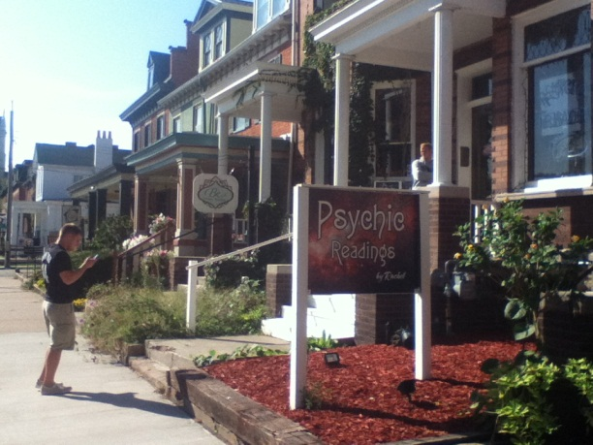
Our group had the Bluff Street district shops. We looked at the couple blocks between 5th and 3rd Streets. There was a combination of types of shops. Many were focusing on tourists, such as a couple Irish shops that we came upon. If they were not touristy like the Bluff Street Time shop, Monks Café, or All Things Sweet, they seemed to draw upon a more local crowd maybe of middle to upper class adults. They all had unique outdoor decorations and windows, creating a very cultural street. All are very small whether they are selling organic foods, like Calico Bean, coffee and beer like Monk’s Kaffee Pub, or the Twisted Root Yoga Studio carrying weekly yoga classes. See the Microsoft Excel Sheet for a list of al l the district shops and businesses. Below, we have described four of our favorite shops, each one’s characteristics, favorite attributes, as well as one’s which could be changed.
Store Name: Shamrock Jewelers
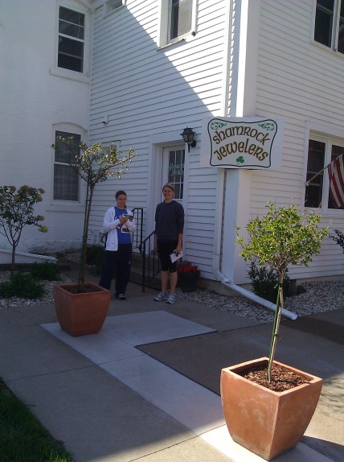
Store Location: 432 West 4th Street, Dubuque, IA
It was interesting to analyze the Shamrock Jewelers shop right off of Bluff Street. We were pulled into this shop because of the shamrock that covered the window outdoors, the locality of it being attached to the store, Shamrock Imports, and the identity of it being Irish. All of these things intrigued us as a group. We raised several questions, such as what types of customers does the shop draw in? Is it authentic Irish? How long has it been here? Does it have anything to do with the store next door? All of these questions were answered when we either walked into the store and looked around or when we talked to the shop owner.
The store is set up to appeal to tourists who come into the area, as is most of the rest of this Bluff Street district. It targets those of middle to upper income, adults of at least middle age, looking for nice jewelry. The store sells a majority of jewelry, not many other objects. We had a conversation with the owner about the history and the beginning of the store. It is cooperating with the Shamrock Imports; he and his wife own both of them. They are of Irish heritage and go back to Ireland every year. In fact, they bring a group back every year, a tourist group to travel around Ireland. He was very friendly and happy to answer any of our questions. My first impression, especially after touring around Shamrock Imports was that there would have been quite a bit of Ireland specific jewelry. However, that was not the case. It was just a bunch of nice jewelry which they use as a large income base for the store. It seemed that the only linkage it had with Ireland was the partnership it shares with Shamrock Imports and the history of the owner.
Personally, I felt that the large sign outside the shop was one of the three best qualities of the shop. It drew people in and made us curious if it was similar to the store next door. It was very ‘Irish’ and appropriate. Secondly, one of the best elements was the soft, Irish music that was playing in the background. Although, the store in general was not promoting Ireland specific jewelry as the majority, it still had a touch of ‘Irishness’ to it. Thirdly, the best element of the store was the general green color that was within the window and sign. I think the color made me wonder what exactly was in the store, and if it was in fact Irish at all.
On the other hand, there were a few things that could have been different. First of all, the location of the store was hidden back more. It was off the street a ways, and I did not even see it right away. Secondly, I think if they were promoting this ‘Irishness’ they lacked some Irish objects or themes in the building. Finally, I felt that they lacked any window objects to really draw people in. There was not much in the window to give passersby’s an idea of what was inside.
Overall, I thought the store was quite intriguing. I was curious about the relationship it had with Shamrock Imports. It was interesting to hear the story behind the stores and what kind of work goes into it. However, the last three things I listed were ones that I would probably change. I think it would be important to make it more noticeable from the street to draw people in more. It was interesting comparing this store with the Shamrock Imports and with those surrounding ones which are not Irish whatsoever.
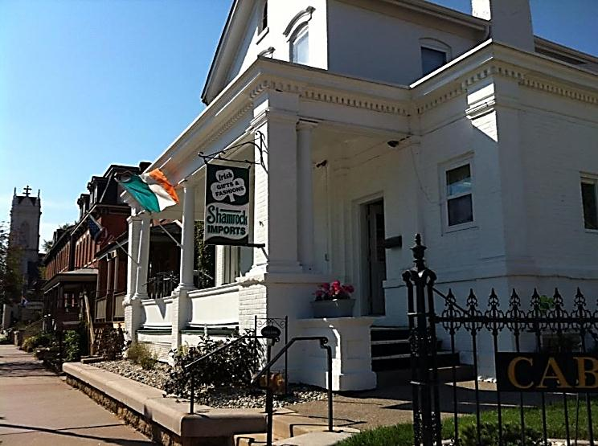
Store Name: Shamrock Imports
Location: 393 Bluff Street, Dubuque, IA
One of the shops that we explored was Shamrock Imports on 4th and Bluff Street in Dubuque. The first impression of the store was that it was the image of the American idea of Irish. The front was white with green accents. Upon entering the front of the store, this shop appeared to be geared more towards a tourist scene. There were shamrock earrings, silverware, and even dog harnesses and collars. There was room after room after room of this type of souvenir. There also included a room of pictures and poems said to be “Irish”. It’s a bit unsure whether or not the poems were actually authentic. The poems were on plaques, music boxes, pictures and more. Upon further investigation of the stores many rooms, it was discovered that this store also hosted many Irish foods and cooking supplies which seems to be a bit more geared to the non-tourist, and more culturally enriched individuals. After talking with the owners of the store, it was noted that they had indeed been to Ireland several times, making the food items all the more authentic. The fact that they had traveled to Ireland made them more knowledgeable about the Irish culture. This made me understand that my first impression of the store was incorrect. I walked through the front doors thinking it was a tourist shop with nothing but items that typical Americans associated with Ireland. Later I learned that this store had something for everyone, the tourists as well as the non-tourists and was actually a very good place to learn more about the true Irish culture.
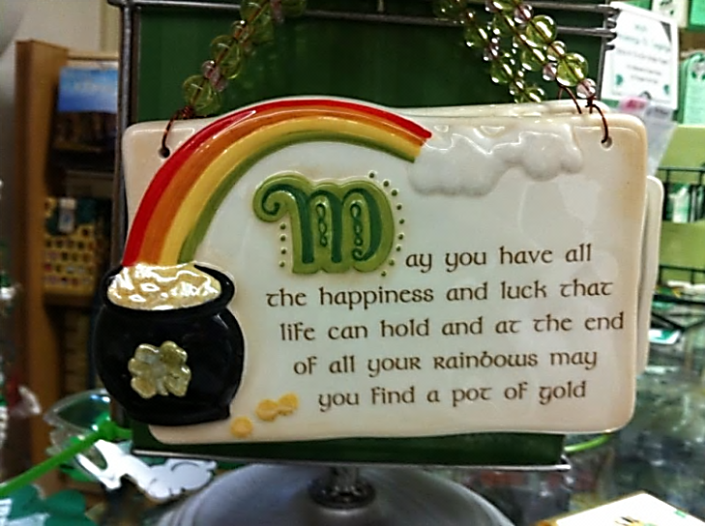
The best things about the store were its location being on the corner of a shopping oriented part of town, the variety of items in the store, as well as the friendliness of the owners and workers. These are the best parts because the location is perfect to draw the attention of all kinds of shoppers and even allows for a small lawn space in front. Once inside, the variety makes the store appealing to all types of people. Finally, the friendly owners and staff make the shop a welcoming environment and one that people would love to return to.

There are a few things that the shop could improve upon but the list is slim. First, they could expand on their selection on native Irish items. While they do have a variety in the store currently, there are far more tourist items than non-tourist items. Also, they could move the authentic Irish material towards the front of the shop so that people can find it more easily. The way it was set up currently, customers must navigate through the many rooms in order to get there. While based on the fact that the store is in Dubuque and not Ireland, this seems semi-logical, it would be nice to have a larger selection of traditional Irish items in the front of the store for people to experience. If it were moved to the front, then it is more accessible. Finally, it would be nice to play up the Irish theme on the stores exterior. Majority of the building is white and there are hints of green here and there but it would be nice if the green was expanded on to add more curb appeal.
If I could improve the store front, I would simply add in more decorations outside to captivate people passing on the street. As of now the store front is mainly white with hints of green. There is also an Irish flag but this could be expanded on.

Store Name: Monks Kaffee Pub
Location: 373 Bluff Street, Dubuque, IA
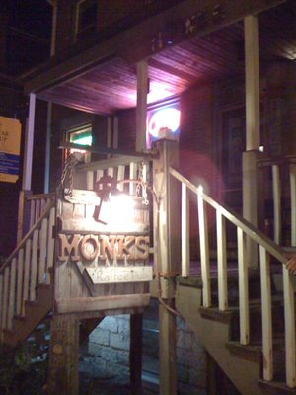
Monks Kaffee Pub is located on the 300 block of Bluff Street. The uniquely named pub is dedicated to the owner’s deceased dog Monk. Deceiving from the outside view, Monks actually is much larger than it appears. There is a bar serving a variety of beers and their specialty—Irish coffee. There is also a lounge area, and a basement which opens on nights when the bar hosts local music talents.
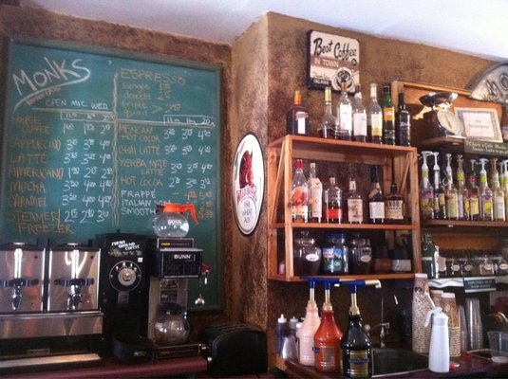
From the feel the group got, the pub has a group of regulars who they appeal to. They attempt to cater to the artistic and cultured crowd with their various artworks and bands on weekends. The target market would have to be described as locals in the 25-40 age range. The first impression of the shop was a friendly atmosphere that people can come to in order to let off some steam, or sit in the lounge and enjoy the free wi-fi.
The best elements of the pub would be the coffee, the large beer variety, and artsy vibe. The worst elements would be lack of food selection (chips and bagels), only a single beer on tap, and the pricing on some of its beers. To improve the pub I would do more advertising to college students and frankly more advertising overall to expose the pub to a larger audience. I would also recommend the shop increase the selection of food and open up a kitchen to feed their hungry guests.
Store Name: Bluff Street Time Shop
Store Location: 411 Bluff Street
Going into the Bluff Street Time Shop, we had no about what we were going to encounter, everybody was curious about what was going to be inside the doors. The time shop is located at 411 Bluff Street. It is located inside a narrow building with a couple doors. We decided to check it out because we had no idea what it was and figured it had the chance to be an interesting shop.
Upon entering the time shop the first thing you see is a lot of watches in multiple glass cases and a wooden floor with tan walls. The first thing you hear is a radio playing with popular music. Our first impression of the store was that wow there are a lot of watches. The shop is composed of 2 similar sized square rooms; in the first room you see wrist watches, the cash register, and a desk with a computer on it.
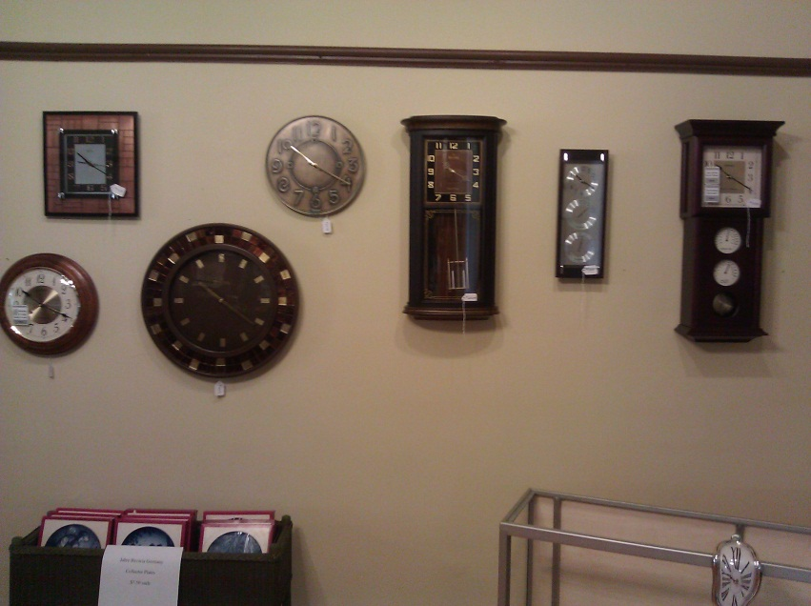
This is where we met the owner of the shop. The owner said that the shop is new to the area; the owner said that he moved into the area from Western Iowa and the Time shop down on Bluff Street has been around for about 4 months. The time shop sells watches and repairs watches. The second room in the shop had a few clocks on the walls and had a really interesting glass case with a cool watch design on the outside. The clocks were really cool because there were so many different styles of clocks. Some clocks had wood framing; others had different types of metal. Some of the clocks had sets of three, others had just one clock. Some of the coolest clocks in the store were the ones with golden pendulums swinging from the bottom of them. They were unique and they were pretty sweet because of how old fashioned that they looked.
My final impression after looking at the store would be that the store was pretty cool and unique. The store is unique because there are not too many if any stores in the Dubuque area that are similar to the bluff street time shop. It was a nice small shop that gave that area of town something it didn’t have. The store was nice and clean, so everything looked nice in the store and it would be a pleasant place to shop if I wanted a watch or a clock. Along with the cleanliness it was good that the radio was playing because it enhanced the atmosphere a bit.
Because the item in the shop would be watches and clocks, the main demographic for the store would be watch collectors and wealthier older people who like nice watches. The type of watches that were in the store seemed like they would be worn by more adult males rather than females. Overall, it was a pretty cool shop and it was neat to look at the variety of watches and clocks. If I were the Owner of the Time Shop I would try to market the store more because it is a new store and nobody has really heard of it. The more people that know that the Time Street is there the higher chances that the business is.

