Switching Languages
Laura Daniela Brinez Camacho
Loras College

Abstract
This study was conducted to identify how many international students at Loras College, switched languages from English to their native language, whichever it was. For the experiment the researcher recorded how many times did people switched from one language to another when having casual conversations during a certain time. The major goal of this research study was to make students aware of what they are doing because sometimes they do it unconsciously and are unaware of it. The results showed that mainly conversations among males and females are the ones that present the most changes of language. Also, conversations among three or more persons tended to have fewer switches. Finally this research has a significant relevance because it can help future studies determine some specific and concrete reason why people use to do this and why it occurs more in a certain type of groups than in others.

Switching Languages
9% of the students at Loras College are international. This not only involves people who talk Spanish, but also, French, Chinese, Indian and Japanese. This being said, I must include myself in that percentage of international students and that’s mainly why I thought in doing this research study. What I was looking for with this research was how many times did international students switched from one language, usually English, to their native languages, either Spanish, French, whichever it was when they were having a casual conversation with another person. I wanted to study this because people sometime do it without being aware of it, and it was interesting to see with actual evidence how many people did it too and with what frequency.
For this study, the variables measured were simply the gender of the people talking, either male of female, just to have and overall idea of whom tended to switch more of language and the number of times they switched languages. Consequently, the hypothesis I got to was that, International Students at Loras College, especially females, tend to switch languages on average more than males. I initially got to this hypothesis because as I am an Internarial student too, I tend to switch my language a lot from English- to Spanish and vice-versa, and overall I though women, tend to talk more, thus they were more propene to switch their language too. The study was done by recording international students in an environment where they felt free to switch from one language to another and where they could have casual conversations without the pressure of having to speak one specific language. This being said, students didn’t need to know I was recording the number of times they switched languages, because that could have possibly influenced the result in the conversation and in fact the results itself of the number of times they changed from one language to another.

Method
Participants
For this experiment, I observed International Students at Loras College, who frequently attend the Intercultural Programs Office, mostly known as the IPO. In total there were thirty-tree individuals evaluated who were picked at random depending on first, if they were international students who spoke a second language different than English, and second, if they started a conversation or not with another student.
Materials
Laptop to record data
Procedure
For the study, I decided to record people for a period of time of hour hours, one hour and a half per day. I went to the Intercultural program Office and sat in a random spot of the place pretending I was doing homework, while I was actually listening if someone was having a conversation and recording how many times they were switching their language. First I looked up at the gender of the students having the conversation and second on how many times did a change occurred. Every time a person changed from one language to another, which counted as a change and when he or she went back to the language they were speaking before, it counted as another change. For my group of study I decided to look for groups of either two or three persons from different genders and record how many times they made a change during a time period of two minutes. If I saw the conversation was over among the individuals before the two minutes ended, I waited for fifteen seconds more and after that, I would switch to another group. The data was recorded in a table specifying the gender of the participants, and the number of times a change occur in each two-minute conversation, with four time intervals and a final column of the total amount of times the students switched their language.
Results
These tables show the relationship of gender groups and the number of times they switched languages in a conversation.
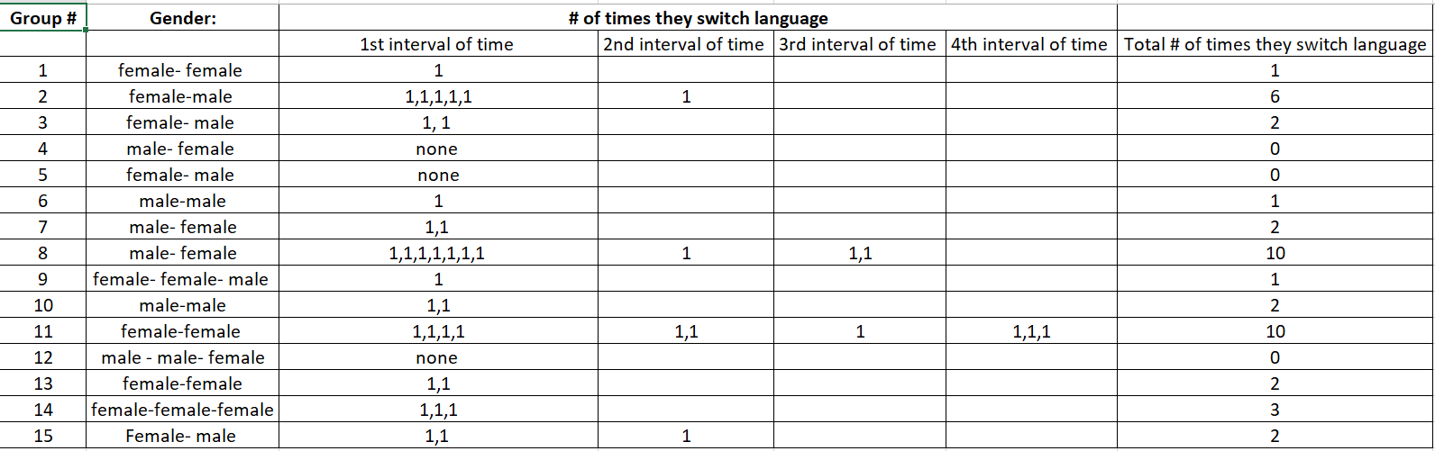
1st table: shows the data when conducting the research
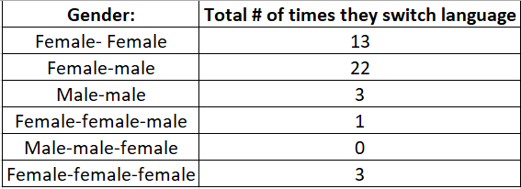
2nd table: shows the data organized and summarized in a way that is easy for the observer to look and understand.
The results show that overall, a female-male and female-female conversations is the one that tends to have more switches in language with averages of 22 (twenty-two) for female-male conversations and 13 (thirteen) for female-female conversations. On the other hand, male-male conversations, and groups with three members were the ones who score the least amount of switches. Male-male conversations got a total of 3 (three) switches and for example, a group made up by male-male-female scored 0 (zero) switches. The group composed of three females also scored 3 (three) switches, also positioned as one of the lowest amount of changes occurred.

Discussion
My initial hypothesis was that International Students at Loras College, especially females, tend to switch languages on average more than males. As I conducted my research I concluded that I was partially right on my hypothesis but it wasn’t completely accurate on some others aspects. For example, when I conducted the research there was a pair of females who switched language 10 (ten) times in a four period time interval. However, after concluding my research, I also noticed that pairs made up by a male and a female tend to switch a lot their language too, for example in one, they switched 6 (six) times in a two period interval and in another, they also switched 10 (ten) times in a three minute interval. The variation in the time intervals might have been mainly because students had a conversation for a minute or two, but after that, they both stopped speaking for a minute and then kept on talking, or they finished the conversation, so I had to stop recording after giving them a fifteen second space.
On the other hand, even though female-male conversations where the most recorded, two of them had no switch of language during the four period interval. Likewise, the groups that were formed by more than two people tend to stay more on one language and it was harder for me to identify whom change when, since there could be multiple conversations at the same time. On the same line, talking about some of the challenges, it was also hard to record people during a two minute interval when they stopped talking and another group started talking and I wanted to record the new group without losing the first one. Moreover, when people were speaking too low and I was trying to pay attention, some could have misunderstand what I was doing and thought I was snitching into their conversation while the only thing i was actually trying to do was recording the amount of changes in language that were occurring. It is challenging when you are located in a place where multiple conversations are occurring at the same time and you want to focus on just a certain part of them. Overall, I could tell that switching languages is not only something I do, but in general most internationals do it too without being aware of it. Also that males-and females are the ones that use to do it more often. For future investigations, researchers should try to find out the actual reason of why people do this (switching languages). Is it because they feel more comfortable doping it? Is it because they gain more confidence when they are talking on that other language? To seem more cool? It would be interesting to see what they can find of all these.

Table

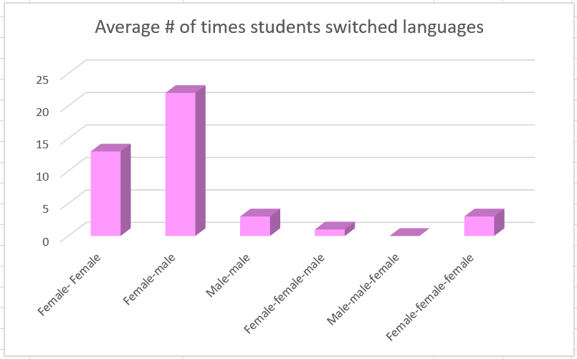Figure 1. Average number of students switched languages.

