Laura Daniela Brinez Camacho
Stock Price Graphing Assignment- Word Part
News: https://www.wsj.com/articles/PR-CO-20180924-909362

Title: Hewlett Packard Enterprise and the World Economic Forum Help Solve World Hunger by 2030

This news article talked about how on sept 24, 2018 at the World Economic Forum Sustainable Development Impact Summit, Hewlett Packard Enterprise and the Forum committed to help solve for world hunger by 2030 through the innovative application of technology. HPE and the Forum are calling on public and private organizations to join them in an open collaboration to find solutions that will eliminate food insecurity and sustainably, nutritiously and inclusively feed a growing population. This is one of the first of several global challenges that need to be solved. HPE believes that technology has the ability to power real societal improvements if applied innovatively and adopted universally," said Antonio Neri, President and CEO, HPE. He also said, "To spark progress, we need a new approach; one that will translate bold ideas into practical solutions. That's why we are partnering with the Forum to bring together the right minds, resources and focus to achieve real-world change, now."

Over the next several months, HPE and the Forum will introduce additional challenges in key industries including financial services, healthcare, transportation and manufacturing. Each challenge will pose a social, economic or environmental problem that could be tackled by convening experts and applying existing and innovative technology in disruptive ways. Through Tech Impact 2030, HPE and the Forum aim to accelerate the transformation of food systems through the innovative application of technology. Building on the work of the Forum's food system initiative, the work will be focused on improving yield, productivity and sustainability across the entire agricultural ecosystem -- fields, factories, grocery stores and the dinner table. So in other words, we are expecting to see more changes in the future from this company and there is going to be more to come.

Summary of findings:

When we look at all companies together we can see that:

For HPE we got this results:

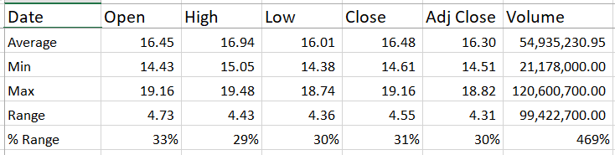Did better on Volume % range

For WDC we got:

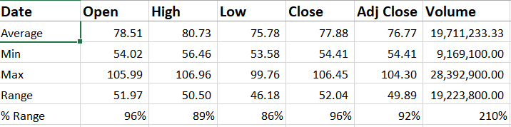 Did better on the others %

And for TXN we got:

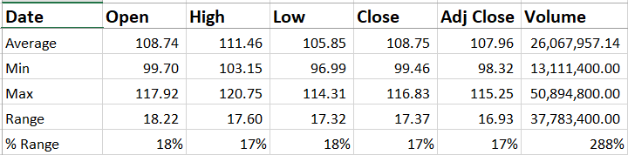 Was the lowest one on general %

Summary of my company: HPE
Hewlett Packard Enterprise is a company operates as a technology company. The company operates through four segments: Hybrid IT, Intelligent Edge, Financial Services, and Corporate Investments. Mr. Antonio Fabio Neri is the current CEO, President and director of the company. Right night the company is at 15.52 with an increase of +0.01 (+0.06%). The market gap is 22.84B. The previous close was in 15.51 and the open was in 15.59. The day’s range vary from 15.31-15.65 and its 52 week range varies from 12.81-19.48. Hewlett Packard volume was 6,231,693 with an average volume of 9,795,987. We can observe that in the graph =, showing a percentage rage in volume of 469%. Overall if we observe the company’s progress in a day it’s going to show it read and decreasing and event until the 6 month period. However when you look at the company in a five year period, we can see that the company has been potentially increasing, and has a good performance, it’s just has gotten low in the past few months. The last data recorded for the company is on Oct 17, 2018, with an open of 15.59, a high of 15.65, a low of 15.31, and adj. close of 15.52 and a volume of 5,724,00. The company’s last revenue was 28,871,000. It had total expenses 26,993,000. Last year company’s net income was 344,000. Same, its total current assets was 21,444,000 and its total liabilities is 37,901,000. Overall, I expect the company to grow and keep on having a good development and increase.

