Outlook

Here is my CIT 110 Outlook Assignment.

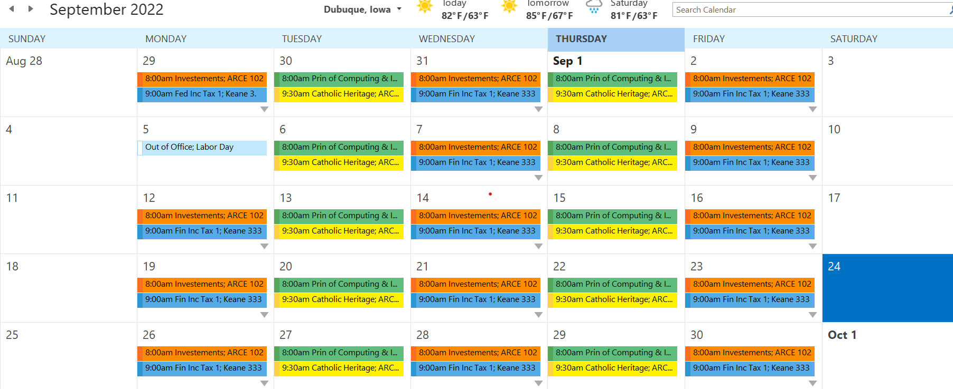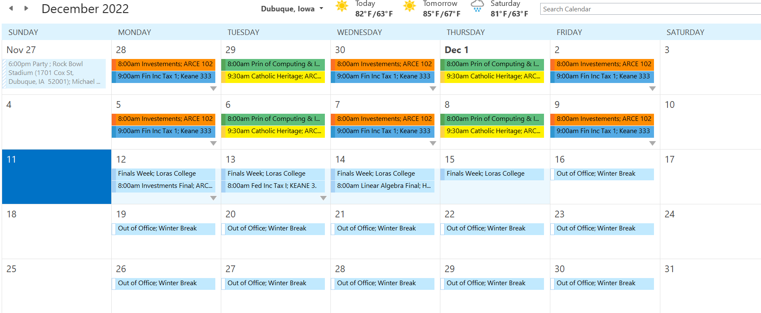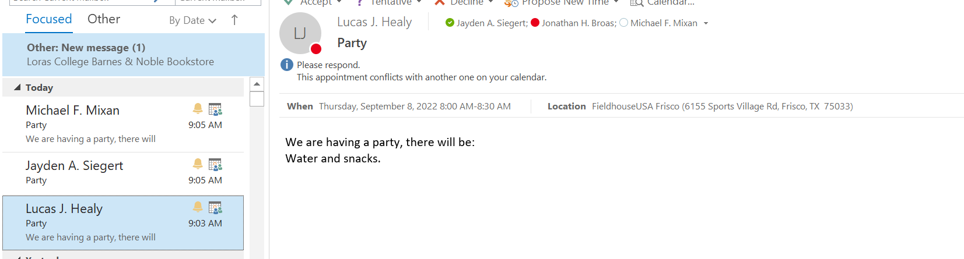

Intro
Hello, my name is Jon. I am on the swimming and diving team here at Loras, and I am a junior. I am currently thinking of coming back for a 5th year and adding a finance major on top of my accounting major, math minor, and religious studies minor. I was born around Beijing, China and my parents adopted me at the age of 3. I grew up in Winona, MN. I have been swimming since 6th grade. I am not very involved in the Loras community; however, I have been wanting to get more involved. I am planning on joining the finance and business clubs to try and work toward being more involved.

Cool Accomplishment
One of the biggest/coolest accomplishments I have achieved, was winning my senior year sections swim meet. We were seeded to win before the meet since we had so much depth. Out of the 4 possible entries for each event, we had at least 3 people place top-16 and most events we had 2 people place top-8. It was definitely one of the happiest moments of my life. It was a really good way to end my high school career. Thankfully, the pandemic happened about a month after the meet.

List of Goals
- 8+ hours of sleep
- 3 meals a day
- Drinking plenty of water
- Make a routine
- B’s or higher
- Exercise 5 times a week
- Take moments to breathe
- Take days for myself
- Save money for rain days
- Secure an internship for this summer
- Work 15 hours a week

