How I Use My Calendar Efficiently
by Thomas Frank
https://collegeinfogeek.com/efficient-calendar-use/

The article states that keeping track of your tasks on a calendar is important because you have a lot of things in your life that you have to keep track of and if you don’t write it down, you may forget about it. A Calendar serves as a quick capture system, or a way to get things you think of written down on something that helps you remember it. A useful way of keeping track of things that you have to do is to color code different types of tasks. For example: You have classes as blue, clubs and activities as green, and other appointments as red. You should check your calendar everyday even if you don’t have a lot to do so you don’t miss anything because you thought that you were free all day. One thing that should be separate from your calendar are smaller tasks. If you put everything that you have to do into your calendar, it becomes cluttered.

Pictures of Calendar:

Months of the semester:
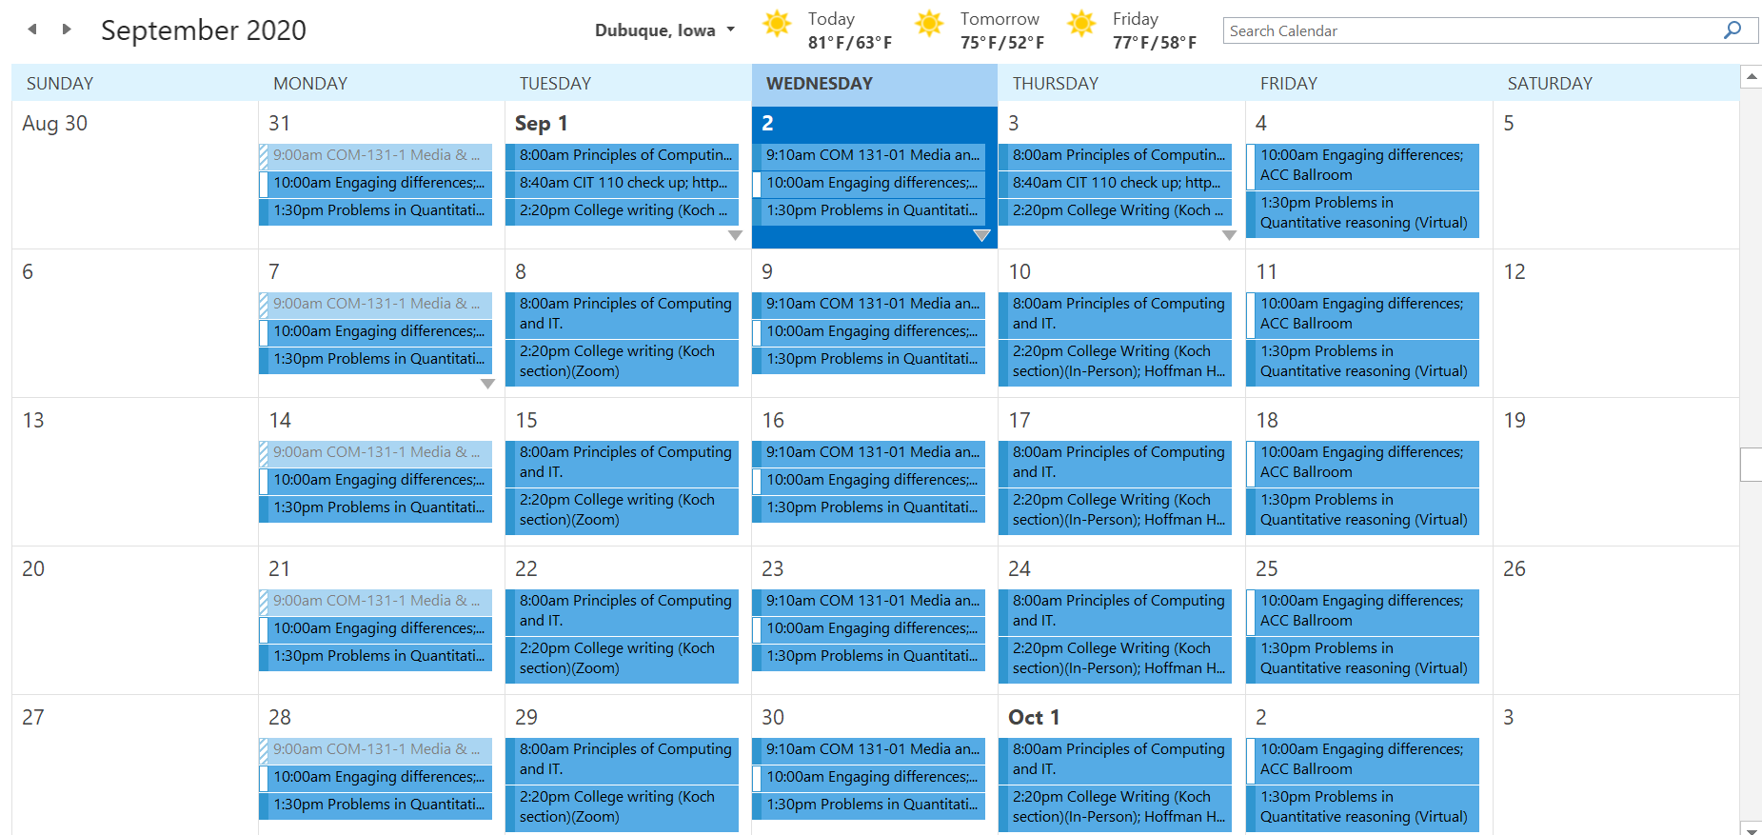
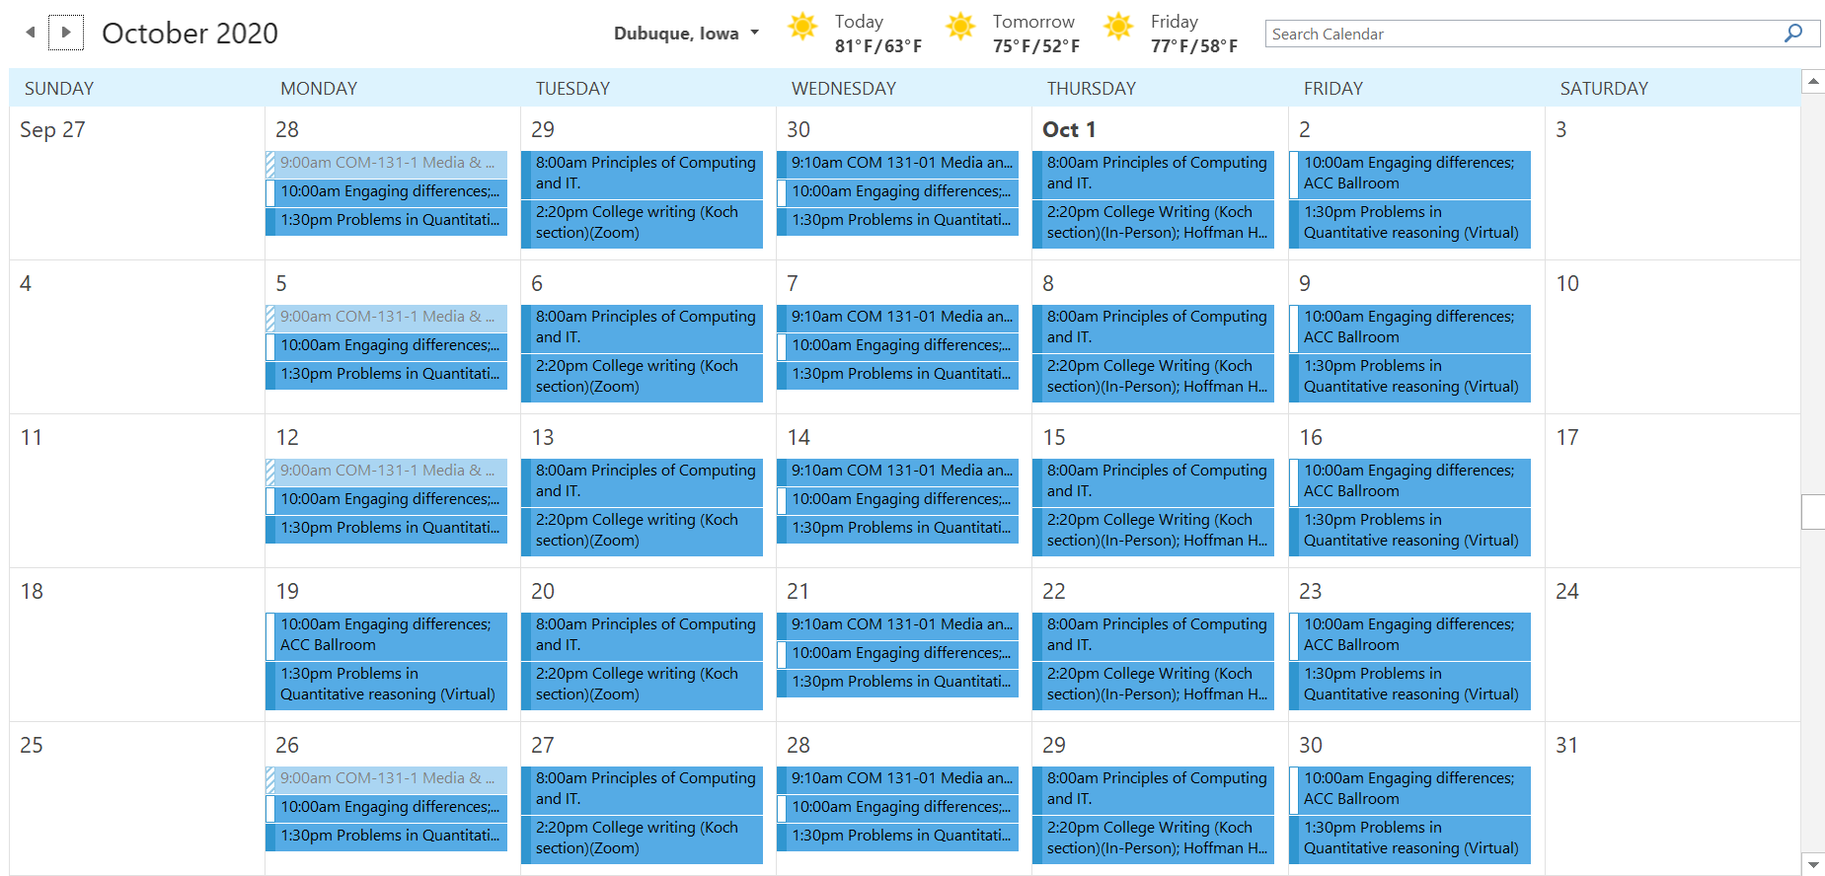
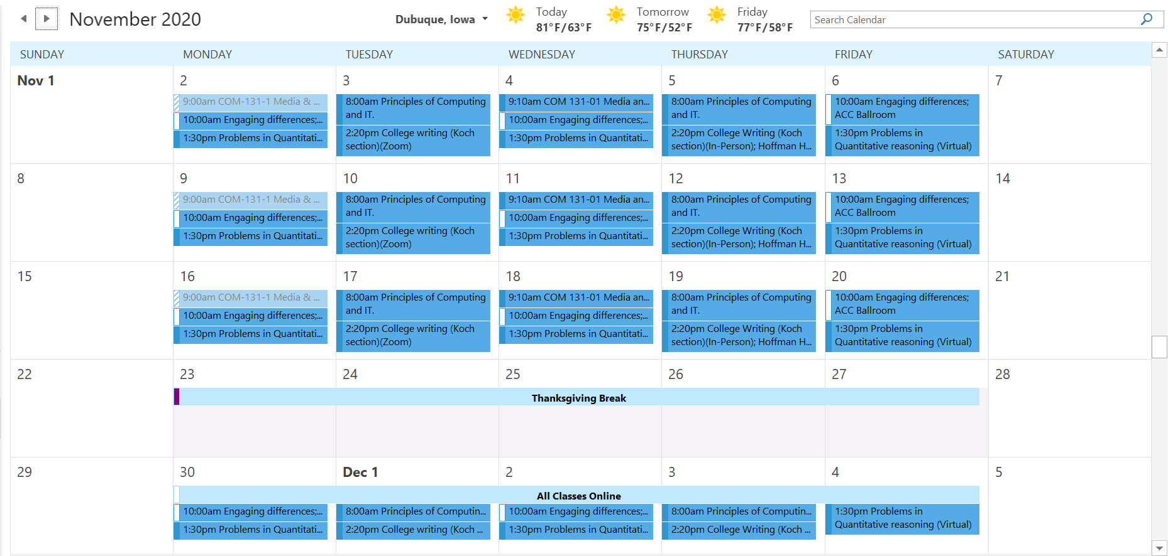
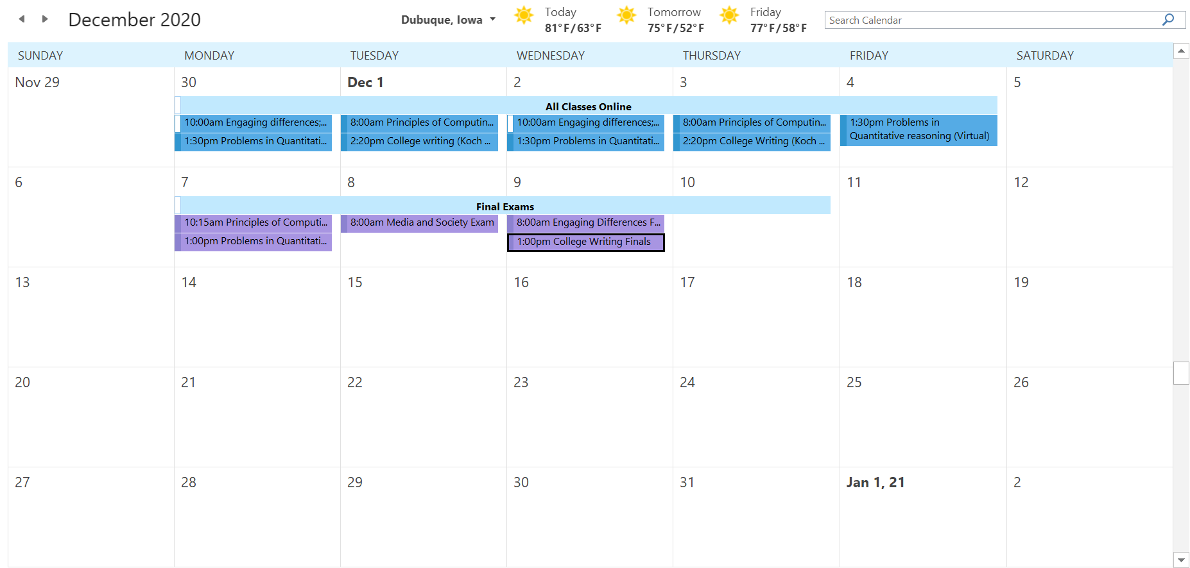

Weekly Agenda:
