Brandon Merz
CIT 110
Outlook Homework
Tips and Tricks Summary
A good way to share work with colleagues you are working with is to share a OneDrive file with them. This will allow everyone to contribute towards the work, and is a better alternative to just sending everyone copies of the work multiple times. When sending an email, you can attach a OneDrive file by creating a new message, clicking on “Attachments,” then “Browse Web Locations,” and looking through the OneDrive section (support.office.com).
There can be messages and conversations that are of little importance to someone. These can be ignored so that any message part of that conversation will automatically be deleted, and you can put more focus into conversations you are part of. By clicking on the message and clicking “Ignore” towards the top left of the mail menu, you get the option to ignore the conversation and delete all messages associated with it. (support.office.com).
It is important to make professional emails feel actually professional. Some ways to do this include making a short subject line that can establish the general idea of the email. There is also looking out for grammatical errors and using a formal greeting to keep the email as a whole formal. Finally, there is keeping everything organized by including bullet points and numbered lists, which can get points across in a neat format (siliconrepublic.com).
When an appointment is set, you might forget about it and needs more than 15 minutes to prepare for it. While the default reminder time is set for 15 minutes before the appointment, this can be adjusted to remind you earlier for any appointments they have. This can be adjusted by clicking on “File,” then “Options,” then clicking on the calendar section. The default reminders can be found under the “Calendar Options” section and adjusted to give you more or less time to prepare (blog.tcitechs.com).
When telling someone about your times, it would be easier to give them your times all at once rather than looking through your calendar and telling them each and every time you are available. The easier way to show someone your times is to share your whole calendar to them. This can be done by opening your calendar and clicking on “Share Calendar” under the “Home” toolbar. You can then enter the email of the recipient of your calendar and then send it to them (blog.tcitechs.com).
If you are trying to get to a certain date on the calendar but want to avoid clicking on a lot of icons in order to get there, you can jump right to that date in the “Go to” section by clicking on “Go to.” This will let you select a specific date to jump to without needing to scroll through multiple weeks and months. You can also click on “Today” in the same “Go to” section and jump to the current date if you are somewhere else on the calendar (fmsinc.com).
Sources:
- https://support.office.com/en-us/office-training-center/outlook-tips
- https://www.siliconrepublic.com/advice/email-etiquette-steps-guide
- https://blog.tcitechs.com/blog/microsoft-outlook-calendar-tips
- https://www.fmsinc.com/MicrosoftOutlook/calendar-tips.htm

Outlook Calendar Snapshots

This is the schedule for January.
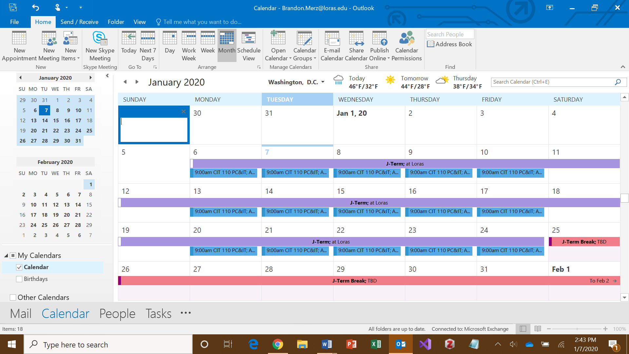

This is the schedule for May (next page).
