After doing further research on tips and tricks of outlook I was able to find a couple of tricks when properly sending an email or even keeping organized. As research was done, of all the things I found, the most interesting trick I found was leaving an out of office reply. This is something I have seen before from a teacher who was out for summer break but I never knew how to actually do my own. These out of office replies are sent to those who are completely unavailable and are not able to respond to an email, hence the name “out of office” reply. The feature is useful for those that are either out on vacation. This can be done by creating a new email and entering the subject and message you’d like for recipients to receive, basically stating that you are not available at the moment. You will then go to your file and save it as an outlook template and finally you’ll click save.
<newemail><subject><file><saveas><saveastype><outlooktemplate><save>
*When typing in the subject make sure to type what you would recipients to read when receiving a message.
Another trick that I found was being able to delay sending an email to a recipient. This trick is used to pretty much withhold an email from being sent until a specified day and time. Doing so instead of you hitting the send button at a specific time, you are able to set up when you would like the email to be sent to your recipient. This process comes in handy, especially for me, when I am up late at night and need to email a teacher early in the morning but I know that I would forget about it. When attempting to do this, when you are on the email composing window you will click options and from then on you will click delay delivery to which a new window will pop open. From there scroll to the one that says “do not deliver before” and add the date in which you want the email to be sent out.
<options><delaydelivery><donotdeliverbefore><close>
*When at the highlighted stage, you will then add the date in which you choose the email to be sent
An easy tip and trick that is useful for your calendar is adding in all holidays without putting them each in one by one. Though this may not be useful for me, others may think this is easier for them when wanting to know of holidays and if and when they forget which holidays are on what days. In order to do this you will click file and click on the options. From there you will click calendar on the side bar and there will be a button that will tell you to add holidays.
<File><Options><Calendar><Addholidays>
Something also easier when attempting to keep organized and trying not to schedule two meetings at the same time is the scheduling assistant tool. This tool will pull up a spreadsheet like agenda with the week and if you are busy with meetings or not. You are also able to plan meetings and set appointments right on the spreadsheet like template (See image 1 below). When attempting to do this all that is necessary is clicking new appointments and then from there, there will be a button that says scheduling assistant to better assist you.
<newappointments><scheduleassistant>
A quick and easy hack I was also able to learn whilst doing my research is going straight to your calendar when opening outlook. It is like a quick shortcut without using the mouse but using two simple keys. Just click Ctrl and the number “2” and your calendar will pop straight up.
<Ctrl><2>
Finally something that can be useful amongst family members or even close business partners would be sharing your calendar with one another. This will allow others to look into different meetings or classes you may be taking throughout your day. In order to share your calendar you would have to click share calendar and just type in the recipients email address. In some cases if you would like to keep a specific meeting private there is a way to keep a meeting hidden. When on your calendar just right click on the event you would like hidden and click “private”
<home><sharecalendar><addrecipient><send>
Image 1

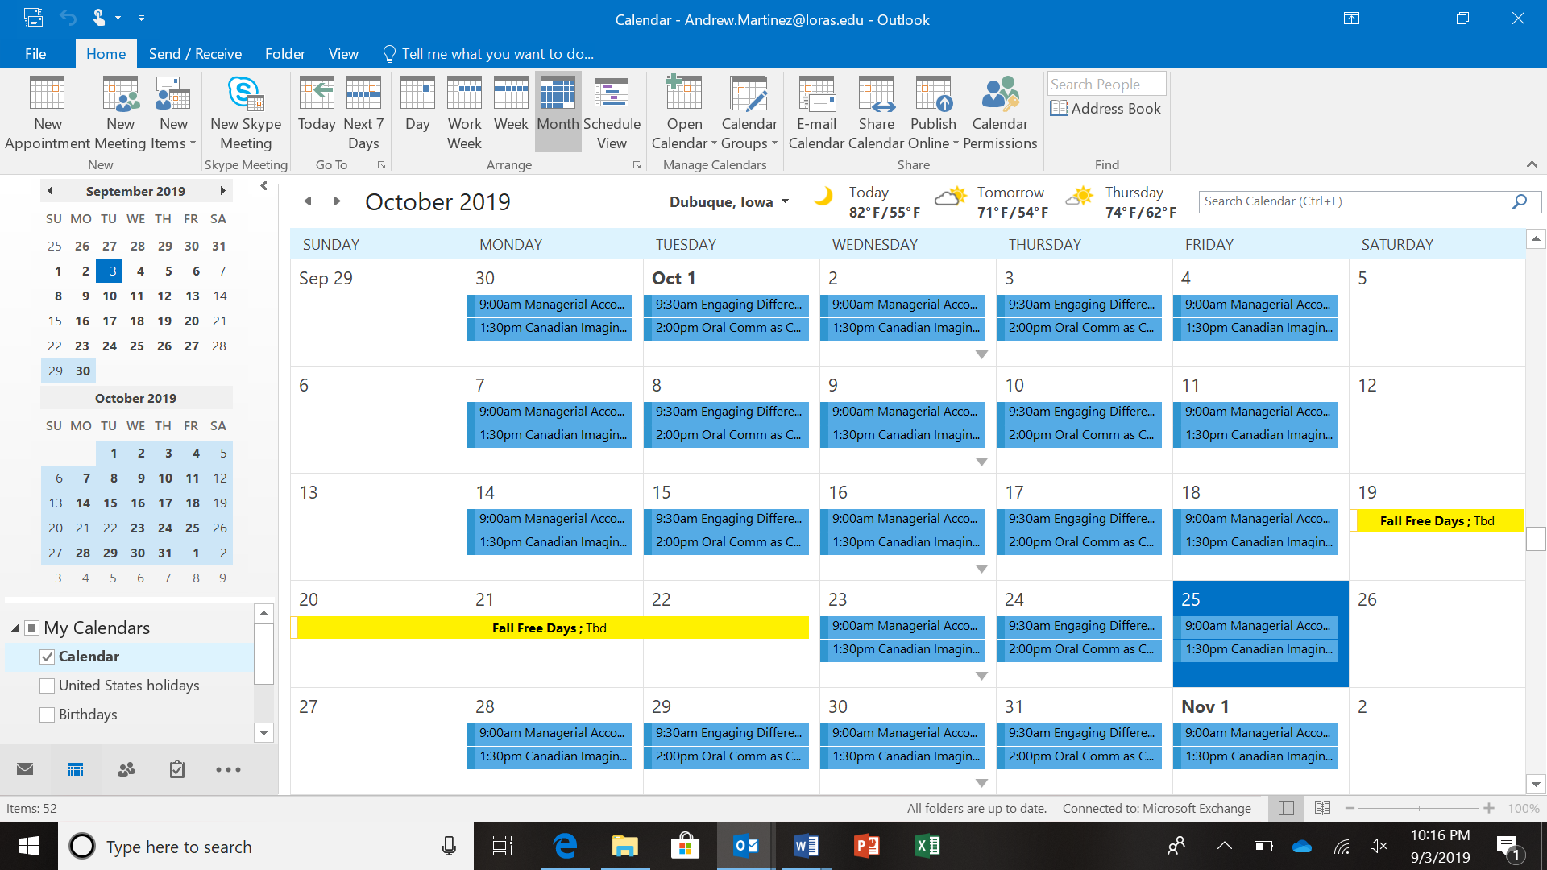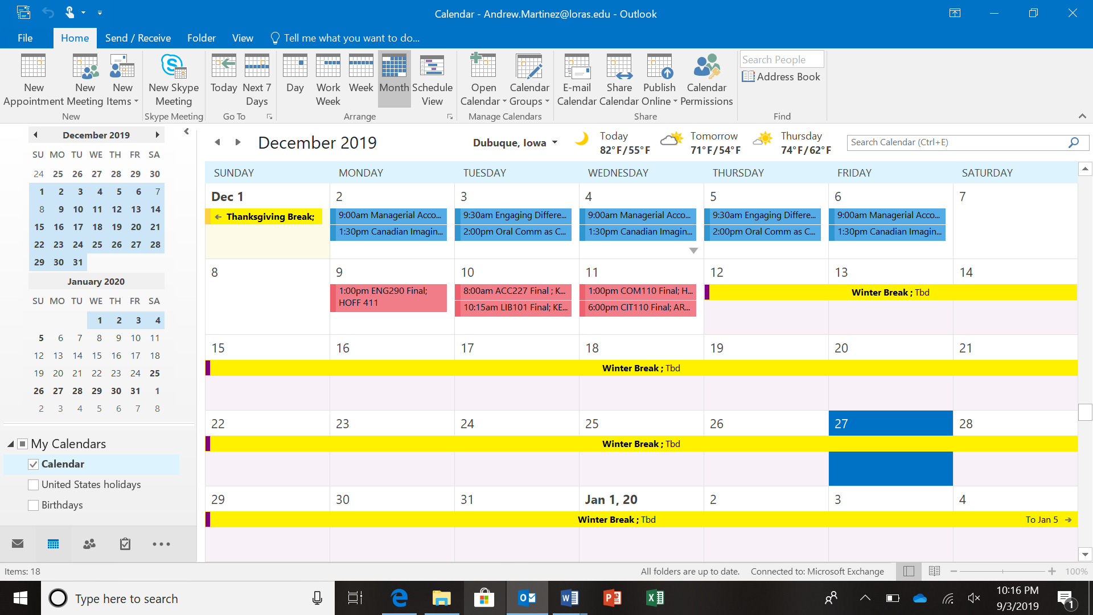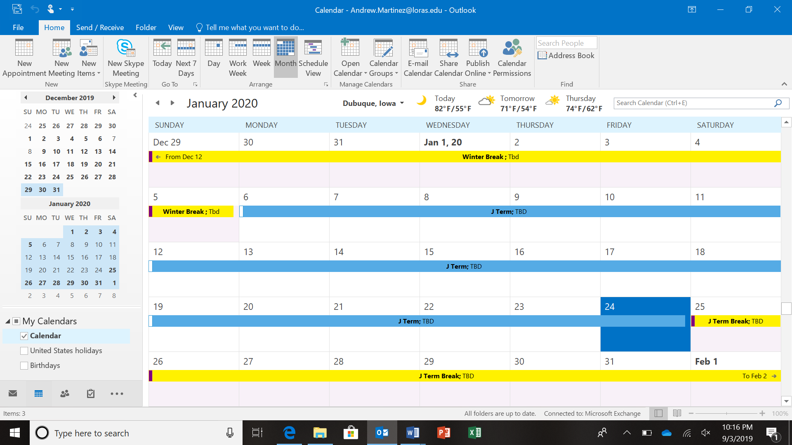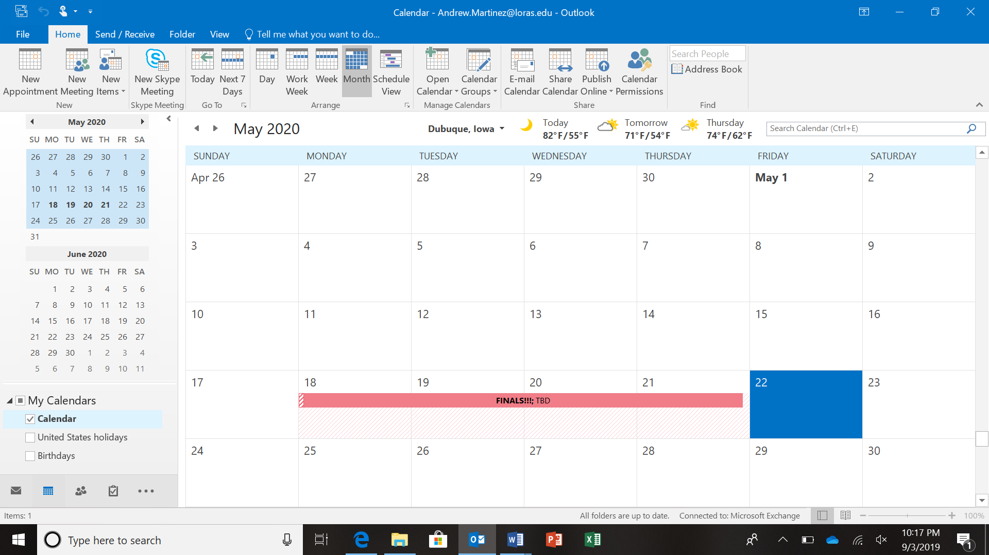

Works Cited
Keeley, J. (2016). 10 Quick Tips to Get Better at Outlook. Retrieved from https://www.makeuseof.com/tag/10-quick-tips-get-better-outlook/
Tschabitscher, H. (2019). How to Set Automatic Replies on Outlook. Retrieved from https://www.lifewire.com/heinz-tschabitscher-1164024
n/a. (2018). 7 Simple Microsoft Outlook Calendar Tips. Retrieved from https://blog.tcitechs.com/blog/microsoft-outlook-calendar-tips

