Outlook
Outlook contains a multitude of different tips and tricks that can help make life easier. These tips and tricks can range from keyboard shortcuts to proper email etiquette. Below are some of the tips and tricks I found to be the most helpful.
The first trick I discover are keyboard shortcuts. Outlook contains a shortcut for almost anything you want to do. Here are how to do three of them. The first shortcut is to create a new email message. To do this you press Ctrl+Shift+M at the same time. The second shortcut is to create a new contact. Which one would perform the action of pressing Ctrl+Shift+C at the same time. The final shortcut is to create a new appointment. That is done by pressing Ctrl+Shift+A at the same time. (Outlook). These shortcuts can save you seconds which can quickly add up to save you a lot of time.
The next tip, or tips I should say, are on email etiquette. The first tip is to make sure that your subject line is simple and to the point. This way when the receiver is looking at it they are able to read the whole subject and easily know what the email is about. The next tip is in regards to opening the conversation. It is important to make it personal by stating the receiver’s first and full name, use a proper creating such as “Hi” but not “Hey,” and to make sure to state your purpose of the email right away. (Short). These tips will help make the recipient of your email take you more professionally.
There are also tricks that can help managing your emails easier. There are two tricks in particular that I found helpful. The first is that there is a way to compose an email and have it sent out at a later time. In order to do this you first compose your email, next you go into Options then to Delay Delivery, to Do not deliver before, and then select the time and date that wish the email to be sent out. The second trick is for blocking specific senders or even countries from sending your emails. You do this by clicking on Home, then Junk email options, then in the new window you choose who you wish to block. (Top 10). These tricks will help make managing your emails that much easier.
By learning tips and tricks about Outlook you can save time and stress by using shortcuts and knowing the proper etiquette.

Works Cited
“Outlook tips and tricks.” Microsoft, https://support.office.com/en-us/office-training-center/outlook-tips
Short, Eva. “You can improve your email etiquette by following these steps.” Siliconrepublic. https://www.siliconrepublic.com/advice/email-etiquette-steps-guide
“Top 10 Microsoft Outlook Tips to Maximize Efficiency.” CMIT Solutions https://cmitsolutions.com/blog/top-10-microsoft-outlook-tips/

Here is my month of January 2020 showing my classes, exam periods, and breaks:
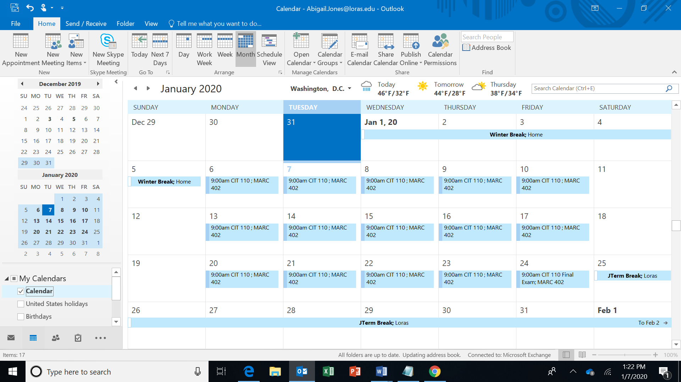

Here is my month of May 2020 showing my classes, exam periods, and breaks:
